Ideation Phase
Define the Problem Statements

Date | 25 December 2025
Team ID
Project Name | Shopez – MERN Stack E-Commerce Platform
Maximum Marks | 2 Marks

Customer Problem Statement Template:
To define the core problems customers and sellers face in online shopping platforms, and use those insights to guide the development of Shopez, a modern MERN-based e-commerce application.

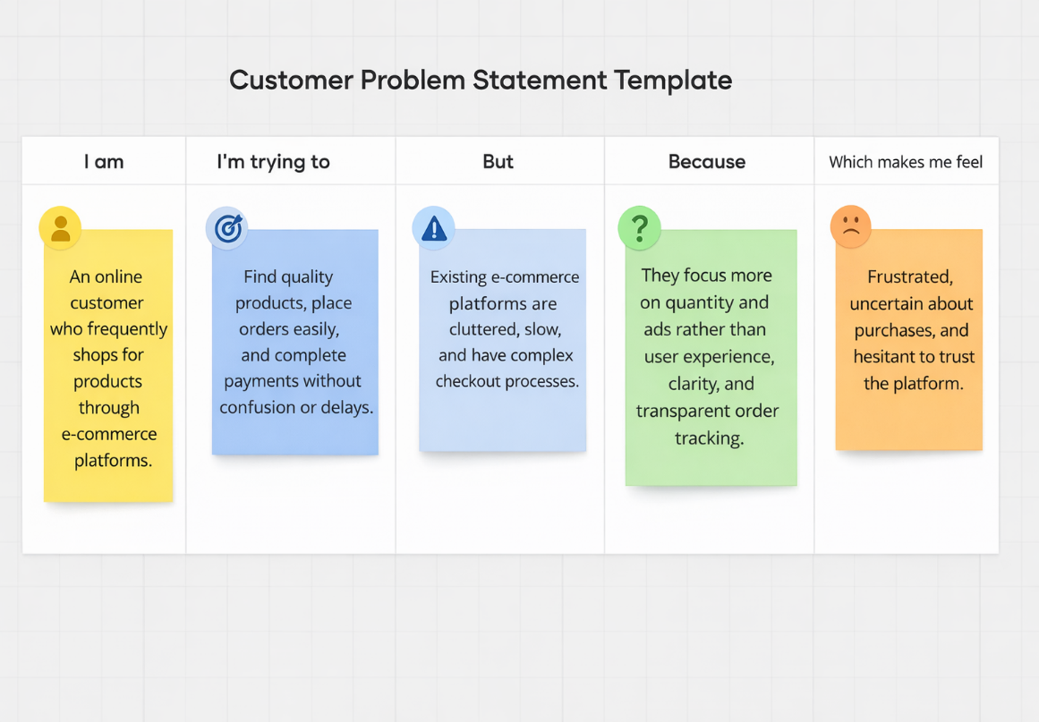

Problem Statements

Problem Statement (PS) | I am (Customer) | I’m trying to | But | Because | Which makes me feel
PS-1 | an online shopper | find reliable products at fair prices | too many platforms are cluttered and confusing | product information and trust indicators are unclear | frustrated and uncertain about purchases
PS-2 | a frequent mobile shopper | place orders quickly and securely | checkout and payment flows are complex | platforms lack simple, user-friendly design | annoyed and impatient
PS-3 | an admin / seller | manage products and orders efficiently | existing systems are difficult to manage | dashboards are not intuitive or centralized | stressed and less productive
PS-4 | a first-time user | track my orders easily | order status updates are unclear | platforms don’t provide transparent order tracking | anxious after placing an order

